University of the People

CS3305 Web Programming 2

Unit 3 Written Assignment 4

Anonymous Student

**Introduction**

**Module 4-6 compelted**

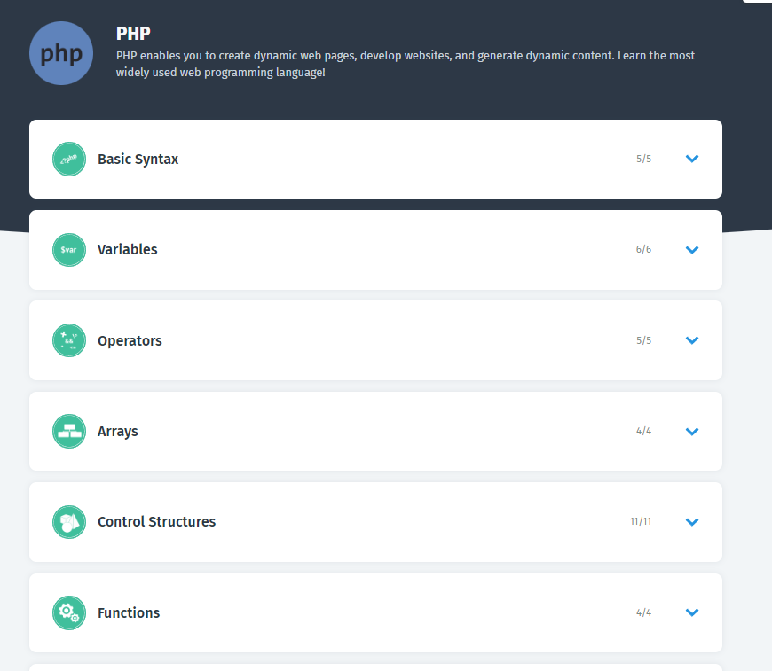

Module 4 completed

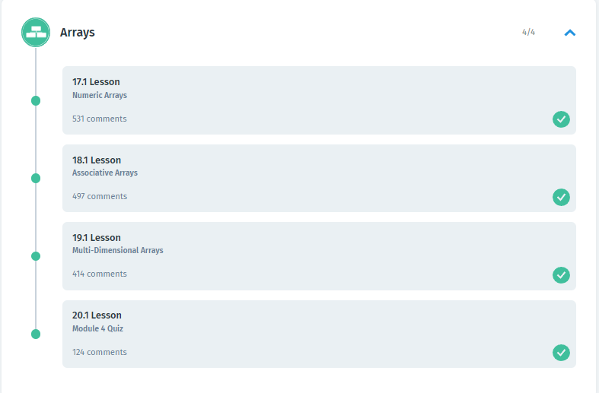

Module 5 Completed

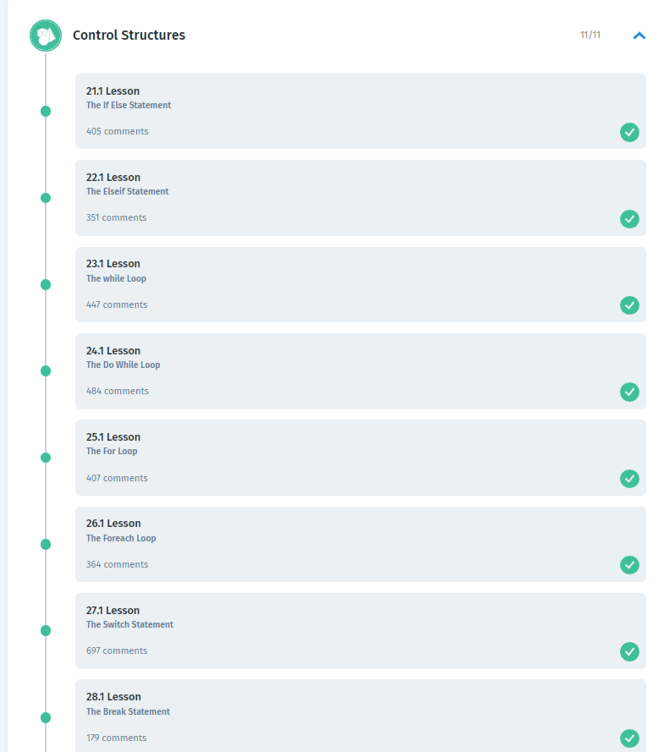

Module 6 completed

